
Mobile App for Direct Market Access for Farmers
1.Sappidi Hemanth - 20221CIT0089
2.Praneeth Sai - 20221CIT0090
3. Vijay kumar – 20221CIT0063

Under the Supervision of: Dr. Mohammad Buran Basha,Assistant Professor
School of Computer Science and Engineering, Presidency University
Program: B.TECH (CSE)

Abstract
The agricultural sector in India faces persistent challenges due to the dominance of intermediaries, lack of transparent pricing, and limited market reach for farmers. Small and marginal farmers, in particular, are often deprived of fair compensation for their produce. This paper proposes the design and development of a mobile application that provides direct market access for farmers, enabling them to connect with consumers, retailers, and wholesalers without dependency on middlemen. The system integrates core features such as digital farmer registration, product cataloging, real-time price updates, secure payment gateway, logistics integration, and multilingual support to ensure inclusivity. Role-based access control is implemented for Farmers, Buyers, and Admins, while blockchain-enabled transaction records and end-to-end data encryption enhance trust, transparency, and security. The methodology includes requirement analysis, system architecture design, prototype development, and usability testing to validate the system’s performance. The proposed solution empowers farmers with better price realization, increases consumer trust through traceable supply chains, and establishes a scalable digital marketplace framework that can integrate AI-based demand prediction and supply chain optimization in the future.

Problem
Farmers in India face exploitation by intermediaries, limited access to wider markets, lack of price transparency, and delays in payments. Existing e-commerce platforms are not tailored to the agricultural sector and fail to address issues like trust, transparency, logistics, and inclusivity for smallholder farmers.

Approach
Develop a mobile application that directly connects farmers with consumers, wholesalers, and retailers. Key features include:
- Farmer & Buyer Login (role-based access)
- Product catalog & real-time price listing
- Secure payment integration (UPI, wallets, net banking)
- Logistics & order tracking
- End-to-end encryption & blockchain-based transaction logs
- Multilingual support for wider adoption

Introduction
Agriculture is vital to India’s economy, yet farmers—especially smallholders—struggle with low price realization, lack of transparency, and dependence on intermediaries. Traditional supply chains reduce profits and delay payments, creating inefficiencies and farmer distress.
While digital platforms are emerging, existing e-commerce solutions are not tailored for agriculture, lacking secure payments, logistics integration, language inclusivity, and trust mechanisms.
This project proposes a mobile application for direct market access, enabling farmers to register, list produce, update real-time prices, and connect with buyers securely. Key features include role-based access (Admin, Farmer, Buyer), multilingual support, secure payments, logistics tracking, and blockchain-based transaction records.
The system aims to eliminate middlemen, ensure fair pricing, and build trust through transparent supply chains, while offering a scalable framework for future enhancements like AI-driven price forecasting and demand prediction.
By leveraging mobile technology, the proposed application aims to empower farmers with fair pricing, eliminate exploitative intermediaries, and enhance consumer trust through traceable supply chains. Beyond immediate benefits, the system provides a scalable framework that can be enhanced with AI-driven demand forecasting, crop price prediction, and supply chain optimization, thereby contributing to a sustainable digital agriculture ecosystem.

II. Literature Review
S.NO | RESEARCH PAPER | AUTHORS | SUMMARY | DRAWBACKS/LIMITATIONS
1 | Linking farmers to markets: Barriers, solutions, and policy options | Wanglin Ma, Dil Bahadur Rahut, Tetsushi Sonobe, Binlei Gong (2024) | The paper reviews barriers that prevent smallholder farmers from accessing markets effectively.  It highlights infrastructure gaps, information asymmetry, transaction costs, and weak bargaining power as major challenges.  Market participation is shown to improve farmer welfare, income, and dietary diversity.  Choice of marketing channel (e.g., cooperatives, intermediaries, e-commerce) strongly influences outcomes.  Farmer cooperatives and digital platforms emerge as promising solutions to reduce costs and improve access.  The authors recommend policies to improve infrastructure, strengthen institutions, expand digital inclusion, and regulate market power. | 1.It is an editorial/review paper, so it summarizes findings from other studies rather than presenting new primary data.  2.The paper gives broad policy directions but does not provide detailed, context-specific strategies for individual regions or crops.  3.Most evidence is country- or case-specific, making generalization to all developing contexts difficult.  4.Barriers such as gender inequality, land tenure issues, and climate risks are mentioned only briefly, without in-depth analysis.  5.The discussion of digital platforms and e-commerce is promising but lacks empirical testing of long-term sustainability.
2 | A digital divide in direct market farmers’ online sales and marketing: Early pandemic evidence from California | Journal of Rural Studies, Vol. 101 (2023) | Surveyed 364 direct-market farmers in California (Jan–Apr 2021) and followed up with interviews later in 2021-22. ScienceDirect  Found that farmers who had an online presence or added online sales after the start of the COVID-19 pandemic (March 2020) were more likely to increase both sales and profitability compared to those who did not use online tools. ScienceDirect  However, farmers who were already using online channels before the pandemic saw increased sales but did not necessarily see increased profitability. ScienceDirect  Identified which farmers are more likely to adopt online marketing: younger, white, female farmers; those with higher gross farm income; and those not growing vegetables. ScienceDirect  Key barriers include: unreliable internet access; lack of money; lack of training or digital skills; and that online sales/marketing may not suit all farms equally. | 1. Because the survey is cross-sectional, causality is hard to establish (e.g., do online tools cause better profits, or do more profitable farms adopt online tools).  2.The sample is restricted to California, which may limit generalizability to other regions with different infrastructure, cultures, or policies.  3. Self-reported data (sales, profitability, use of online tech) can suffer from recall bias or over/under-reporting.  4. The time frame (first ~10 months of COVID) captures an unusual period—pandemic disruptions may drive effects that don’t persist once things normalize.  5.“Vegetable growers” being less likely to use online sales may reflect perishability / logistic challenges, yet the study may not fully quantify those extra costs.
3 | E-Commerce for Agriculture | E. S. Soegoto & A. Nugraha (2020), IOP Conf. Ser.: Materials Sci. Eng. | 1.The paper is a descriptive / literature survey that reviews existing journals to understand how e-commerce is being (or can be) used by farmers. IOPscience+1  2. It argues that tools like websites, social media, advertisements, and broader e-commerce marketplaces help farmers market their products, expand distribution areas, and reach buyers outside their immediate region. ResearchGate+1  3.Key benefits noted are facilitating transactions, knowing availability of goods, and ease of access to platforms as both seller and buyer. ResearchGate+1  4. It cites “place a sales ad” and “place a request ad” features (where buyers or consumers can also request what they want) as useful mechanisms in marketplace platforms. ResearchGate  5.The paper concludes that e-commerce is helpful for increasing income for farmers by lowering barriers to market access, improving visibility, and simplifying marketing effort. IOPscience+1 | 1. Because it is a descriptive / secondary review (not based on new empirical data), it does not provide quantitative evidence on how much income increases, or precisely how much e-commerce improves outcomes. IOPscience+1  2. “Descriptive method” means there is little to no testing of causality, i.e. whether e-commerce causes benefits or whether farmers who are already in better positions adopt it more easily. ResearchGate+1  3.Context is quite general (Indonesia, literature broadly) — local constraints (e.g. logistics, digital literacy, internet connectivity quality) are mentioned only lightly, not deeply analyzed. ResearchGate  4.Does not address in detail the costs and challenges of implementing e-commerce platforms (e.g. maintenance cost, ensuring quality, handling perishable products, trust / payment systems). ResearchGate+1
4 | eKichabi v2: Designing and Scaling a Dual-Platform Agricultural Technology in Rural Tanzania | Raghunath et al. (2024), arXiv | 1. The authors survey 1,014 agricultural households in Kagera, Tanzania to understand device ownership, USSD (feature-phone) use, and comfort with digital tools in rural settings. arXiv+1  2. They develop a dual-platform directory of ~9,833 agriculture-related enterprises accessible via (a) a USSD application for feature-phones and (b) an Android offline app for smartphones. arXiv+2arXiv+2  3. The system is designed to bridge the capabilities gap: for users who cannot use the Android app well, they pilot mobile money agents (wakalas) as intermediaries to help USSD users. arXiv+3arXiv+3arXiv+3  4.In deployment, they find that USSD is heavily used even by smartphone owners, due to reluctance to install apps or limited digital skills; but the Android app enables richer interactions, more efficient search, and better information retention. arXiv+1  5. As the directory scales (more businesses, more users), the limitations of USSD in terms of depth, menu complexity, response latency, and user burden become more evident. arXiv+1 | 1.The study is localized to one region (Kagera, Tanzania); results may not generalize to other rural areas with different infrastructure, norms, or farmer networks.  2. Because the directory is deployed as part of a pilot study, uptake and use may be influenced by project incentives or research support, which might not persist in fully independent real-world operations.  3.USSD’s inherent constraints (menu depth, session time limits, limited interaction complexity) limit the richness of service possible for feature-phone users, especially as directory size increases.  4.The system depends on intermediaries (wakalas) for usability bridging, which adds operational overhead, costs, and reliance on third parties.  5. The study focuses largely on information access (directory lookup), but less on its downstream impact (e.g. actual changes in sales, incomes, adoption of new buyers) over a long period.
5 | Digital agriculture report: Rural e-commerce development experience from China | FAO & Zhejiang University (2021) | 1. The report examines how rural e-commerce in China has driven digital transformation of agri-food systems—boosting production efficiency, expanding market access for farmers, reducing poverty, and encouraging young people to return to rural areas. FAOHome+2Zhejiang University+2  2.It emphasizes the importance of an enabling ecosystem: strong government policy, favorable regulations, public-private partnerships, infrastructure (internet, logistics, digital payments), and supportive business models. Open Knowledge FAO+2ECNS+2  3. The report documents concrete case studies: “Taobao villages” (rural villages where a significant fraction of households operate online stores) are highlighted as a successful model of rural revitalization through e-commerce. Zhejiang University+2Open Knowledge FAO+2  4.Data show that by 2020, most administrative villages were fiber/4G-connected; many rural households had internet access, and rural online retail sales (including agricultural products) had reached large volumes and high annual growth rates. FAOHome+3Zhejiang University+3Open Knowledge FAO+3 | 1. Because the report is broad and national in scope, it sometimes lacks granular quantitative data about how much specific interventions cost vs how much value they generate (e.g. for smallholder farms).  2.Infrastructure improvements are heavy investments; the report acknowledges uneven development in remote or less-favored regions (logistics, internet, electricity). These gaps may limit replicability in areas with weaker infrastructure. Open Knowledge FAO+1  3. Digital literacy / skills among farmers is uneven; many may not be able to take full advantage of the platforms unless supported by training. This is recognized as a bottleneck. Open Knowledge FAO+1  4. The report tends to focus on success stories; it may under-represent failures or cases where e-commerce is less effective or unsustainable.  There is potential for inequality: small producers, women, poorer rural households might not benefit equally, due to lack of capital, access to markets, or capacity to meet quality, packaging, or logistical demands. Open Knowledge FAO
6 | Addressing Information Processing Needs of Digital Agriculture with OpenIoT Platform | Jayaraman, P. P. et al. (2015), Springer | 1.The paper investigates how the Internet of Things (IoT) can help address challenges in agriculture, particularly around data collection, processing, and decision-making. SpringerLink  2. It introduces the OpenIoT platform (an EU-FP7 project) as middleware that enables agriculture applications to access, integrate and query heterogeneous sensor data streams, including semantic discovery of sensors and data sources. SpringerLink  3. A use case called Phenonet (by CSIRO, Australia) is built using OpenIoT: it deploys environmental sensors (soil, climate etc.) to monitor crops, gathering data for analysis. SpringerLink  4. The system enables users to discover sensors via SPARQL queries, handle sensor metadata, process data streams, and build value-add applications over those streams (e.g. monitoring, analytics). SpringerLink | 1.Because it’s fairly early (2015) and fairly technical, the paper focuses on data/infrastructure and middleware aspects but doesn’t deeply engage with socioeconomic, adoption, or farmer behavior issues (which are critical in real agriculture settings).  2.The evaluation is mostly in terms of technical feasibility; there is less evidence about impact on actual farmer outcomes (yields, profits, costs, etc.).  3. Dependence on sensors, networking infrastructure, power, and continuous connectivity may limit usability in remote rural areas with intermittent power or poor internet.
7 | Mobile Application for Direct Market Access for Farmers | Akshaya N., Subash M., et al. (2025), IJRASET | 1. The paper presents a mobile application designed to help farmers access markets directly by cutting out intermediaries; features include real-time pricing info, inventory tools, direct buyer communication. IJRASET  2.It incorporates GPS-based location tracking, digital payments, and market trend analysis to help farmers make more informed decisions. IJRASET  3. The app is built to work even in low connectivity areas: supports offline functionality and is tailored to low-end smartphones. IJRASET  4. They conducted a pilot evaluation with farmers via surveys and user feedback, measuring effects on market access, earnings, and reduction in dependence on middlemen. IJRASET | 1. The pilot is likely small-scale and context-specific; results may not generalize to all rural areas with different infrastructure or market ecology. IJRASET  2.Dependence on smartphones (even if low-end) and internet connectivity remains an issue; offline support helps but may not fully offset connectivity or device limitations. IJRASET  3.Digital literacy among farmers can be low; user training or support is needed and may add cost/complexity. IJRASET  4.Buyer engagement (ensuring enough demand & reliable buyers) is a challenge; without sufficient buyers, farmers may not get consistent benefit. IJRASET  5. The paper seems to focus more on income and market access metrics; long-term sustainability (maintenance, scaling, operational costs, logistics) is less deeply explored. IJRASET
8 | A Digital Farmer Marketplace Connecting Rural Farmer and Consumer without Middle Person | Pavendan, VijayShena, Lokeshwaran, Dhanasekar (2025), IJRASET | 1.Objective: Develop a user-friendly digital marketplace to connect rural farmers directly with consumers, eliminating intermediaries.  2.Features:  - Real-time price updates  - Product listings  - Direct communication channels  - Logistical support for transactions  3.Design:  - Offline support  - Multilingual interface  - Intuitive navigation  4. Goal: Empower farmers by enhancing market reach and promoting fair trade. | 1. Digital Literacy: The effectiveness of the platform may be limited by the users' familiarity with digital tools.  2.Infrastructure: Dependence on internet connectivity and electricity could hinder accessibility in remote areas.  3.Market Reach: Ensuring a sufficient number of consumers to match the supply from farmers is crucial for the platform's success.  4.Scalability: Expanding the platform to cover a larger geographic area may require significant resources and adaptation to local contexts.
9 | Farm to Home: An e-commerce Application for Farmers and Consumers | N. Anusha, Manyam Ramakrishna Reddy, et al. (2024) | 1. Objective: Develop a user-friendly digital marketplace to connect rural farmers directly with consumers, eliminating intermediaries.  2. Features:  - Real-time price updates  - Product listings  - Direct communication channels  - Logistical support for transactions  3. Design:  - Offline support  - Multilingual interface  - Intuitive navigation  4. Goal: Empower farmers by enhancing market reach and promoting fair trade.  5.Target Audience: Farmers with varying levels of digital literacy.  6. Significance: Addresses the challenges faced by farmers in accessing reliable markets and aims to modernize agricultural trade through digital solutions. | 1.Digital Literacy: The effectiveness of the platform may be limited by the users' familiarity with digital tools.  2.Infrastructure: Dependence on internet connectivity and electricity could hinder accessibility in remote areas.  3.Market Reach: Ensuring a sufficient number of consumers to match the supply from farmers is crucial for the platform's success.  4.Scalability: Expanding the platform to cover a larger geographic area may require significant resources and adaptation to local contexts.  5. Sustainability: Long-term maintenance and updates to the platform are necessary to keep it relevant and functional.  - Regulatory Challenges: Compliance with local agricultural and trade regulations may pose obstacles.
10 | Contract Farming and Food Insecurity in an Open Competitive Economy: Growth, Distribution, and Government Policy | Das, Bhattacharyya, Marjit (2023), Journal of Risk Financial Management | Objective: The paper explores the emergence and consequences of contract farming (CF) as a new subsector in agriculture within a small open developing economy, applying the theory of finite change in a general equilibrium framework. MDPI  Key Findings:  - Economic Growth: CF increases GDP and aggregate economic welfare.  - Income Distribution: CF may lead to more skewed income distribution.  - Food Production: CF reduces domestic production of food crops.  - Food Insecurity: CF increases food imports, potentially leading to food insecurity.  - Policy Implications: Governments may need to restrict CF to preserve social welfare if non-food-producing sectors expand, causing terms-of-trade deterioration for food-importing nations.  Methodology: The study employs a variant of the 3 × 3 mixed specific factor-Heckscher Ohlin general equilibrium model of production and trade, incorporating finite changes to analyze sectoral diversification and the emergence of CF. MDPI | 1.Scope: The paper focuses on theoretical modeling and does not delve into empirical data or case studies to validate the findings.  2.Assumptions: The model assumes a small open economy and may not account for larger, more complex economies where CF dynamics could differ.  3.Policy Recommendations: While the paper suggests restricting CF to preserve social welfare, it does not provide detailed policy frameworks or strategies for implementation.  4.Data Limitations: The study relies on secondary data from the FAO and may not capture the most recent developments or variations across different regions.

III. System Design and Architecture

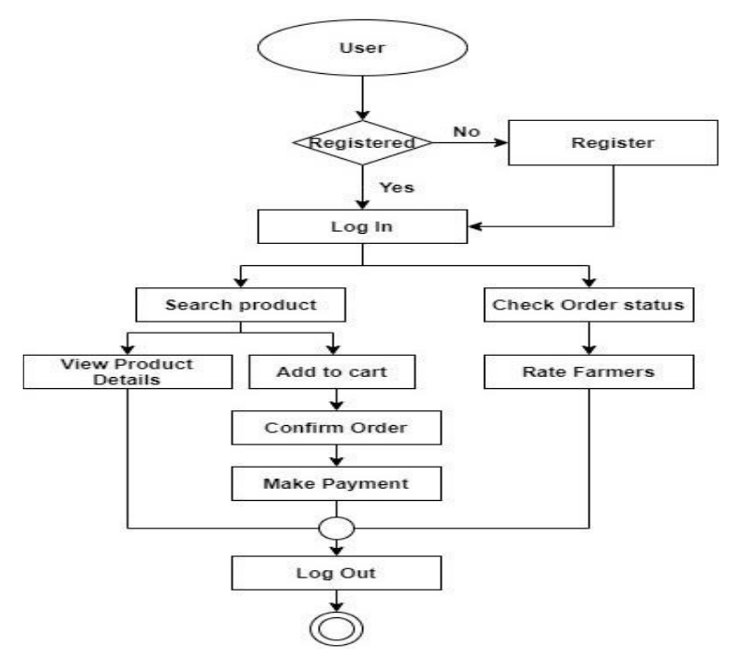

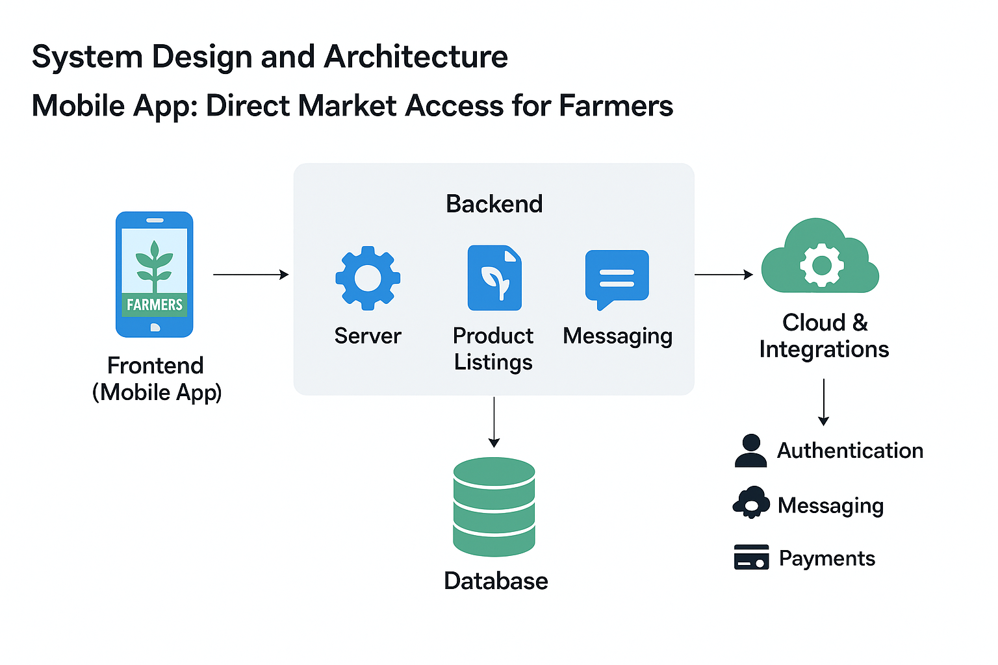
IV. Algorithm Details
Algorithm 1: Farmer Authentication & Sync
Objective: Authenticate farmer/buyer and sync details to database.
Steps:
- User enters credentials (email/password OR social login).
- Authentication service (Clerk/Auth0/Firebase) verifies credentials.
- On success → session token generated.
- Event trigger → backend function listens.
- User details stored in MongoDB (userId, role: farmer/buyer, name, email, image, location).
- Redirect user to dashboard (Farmer Dashboard OR Buyer Dashboard).

🔹 Algorithm 2: Product Listing by Farmers
Objective: Allow farmers to add products for sale.
Steps:
- Farmer selects “Add Product” option in mobile app.
- Inputs product details: {name, category, price, quantity, image, location}.
- App sends details → backend API.
- Backend validates (price > 0, quantity > 0).
- Store record in products collection with farmerId.
- Send success response → update farmer dashboard.
- Product appears in buyer’s marketplace feed.

🔹 Algorithm 3: Buyer Order Placement
Objective: Buyers place orders and pay directly.
Steps:
- Buyer browses product catalog.
- Selects product → enters required quantity.
- Backend checks availability (stock ≥ requested qty).
- If valid → lock stock temporarily.
- Buyer proceeds with payment (Stripe/Razorpay).
- On success → create order record {orderId, buyerId, farmerId, productId, quantity, price, status}.
- Update product inventory in DB.
- Send notification to farmer.
- Buyer sees confirmation in order history.

🔹 Algorithm 4: Real-Time Messaging (Farmer ↔ Buyer)
Objective: Enable direct chat for negotiation & queries.
Steps:
- Buyer opens chat with farmer.
- Sends message via WebSocket API.
- Backend validates chat session (linked to product/order).
- Store message in chat collection with timestamp + senderId.
- Push message to recipient in real-time.
- Both users see live updates.

🔹 Algorithm 5: Order Tracking & Delivery
Objective: Track delivery from farmer to buyer.
Steps:
- Farmer updates order status → {Packed, Shipped, Delivered}.
- Backend updates order record in DB.
- Push notification sent to buyer.
- Buyer views status on tracking page.
- Buyer confirms delivery + leaves feedback.
- System updates rating for farmer.

V. Module Description
🔹 1. Authentication Module
- Purpose:
Provides secure login and registration for both farmers and buyers. Ensures only verified users can access the platform, and manages session handling for seamless app usage.
- Technology Stack:
  - Firebase Authentication: Supports email/phone/social logins.
  - Firestore Database: Stores user details (userId, role: farmer/buyer, name, phone/email, profile image).
- Functions:
  - Sign in / Sign up: Farmers and buyers register using mobile number, email, or social login.
  - Session Management: Maintains active sessions securely.
  - Role Assignment: Differentiates between farmers (who can upload produce) and buyers (who can place orders).
  - Data Sync: On new user creation, details stored in Firestore.

🔹 2. Farmer Product Management Module
- Purpose:
Enables farmers to upload, update, and manage product listings. Ensures buyers see real-time availability of crops and prices.
- Technology Stack:
  - Firestore Database: Stores product details (name, category, price, stock, images).
  - Cloud Storage: Stores product images securely.
- Functions:
  - Add Product: Farmers upload crop details (price, quantity, image).
  - Update Product: Farmers can edit details or adjust stock.
  - Delete Product: Farmers can remove unavailable produce.
  - Real-Time Updates: Any changes instantly reflected in buyers’ marketplace feed.

🔹 3. Order & Payment Module
- Purpose:
Facilitates buyers to place orders and make secure payments directly to farmers. Maintains transparent order tracking and history.
- Technology Stack:
  - Payment Gateway (Razorpay/Stripe/UPI): Handles digital transactions.
  - Firestore Database: Stores order records (orderId, buyerId, farmerId, productId, quantity, total price, status).
- Functions:
  - Place Order: Buyer selects product and confirms order.
  - Stock Validation: Backend checks if requested quantity is available.
  - Payment Processing: Secure digital payments via UPI/cards.
  - Order Tracking: Farmers can update status (Packed → Shipped → Delivered).
  - Order History: Buyers can view past orders and invoices.

🔹 4. Chat & Communication Module
- Purpose:
Provides real-time messaging between farmers and buyers for negotiation and query resolution.
- Technology Stack:
  - Firebase Realtime Database / WebSockets: For instant, bi-directional communication.
  - Firestore Database: Stores chat history and media references.
- Functions:
  - Real-Time Messaging: Messages delivered instantly between farmer and buyer.
  - Chat History: All messages stored in DB for reference.
  - Media Sharing: Support for images, receipts, or delivery proofs.
  - User Presence Indicators: Shows when the other user is online/typing.

🔹 5. Notification Module
- Purpose:
Ensures farmers and buyers receive instant updates for orders, payments, and market alerts.
- Technology Stack:
  - Firebase Cloud Messaging (FCM): Push notifications.
- Functions:
  - Order Notifications: Farmers alerted for new orders.
  - Payment Confirmation: Buyers receive instant receipts.
  - Status Updates: Buyers notified when order is packed, shipped, delivered.
  - Market Alerts: Farmers notified of nearby demand/prices.

🔹 6. Error Monitoring Module
- Purpose:
Tracks and logs system errors to maintain reliability. Helps developers quickly identify and fix issues.
- Technology Stack:
  - Sentry (or Firebase Crashlytics): For error tracking and monitoring.
- Functions:
  - Error Capture: Detect runtime errors, crashes, and failed transactions.
  - Error Logs: Detailed logs stored with stack traces.
  - Developer Dashboard: Provides insights into bugs and issues.
  - Alerts: Sends notifications to developers for critical failures.

